Abstract
The fundamental thermodynamic process of isothermal, isovolumetric, isobaric, and adiabatic transformations is explained in this report with a particular focus on simulation of isobaric process. The isobaric process is a thermodynamic process in which pressure is kept constant and volume and temperature are varying in accordance with Charles’ Law that a gas is directly proportional to its temperature when pressure is kept constant. This experiment is conducted with an aim to analyze the relationship between these parameters and validate theoretical predictions in a simulated setup. The findings obtained indicate a direct proportionality between volume and temperature in an isobaric process and graphical analysis as per theoretical predictions. Comparative simulation of isothermal and adiabatic transformations is carried out to reinforce an understanding of thermodynamic transformations. A critical analysis of findings obtained is discussed in this report with a discussion of notable observations and implications in real-world applications such as heat engines, refrigeration cycles, and atmospheric phenomena.

Introduction
Thermodynamic processes describe how gases respond under changing constraints and are applied in a vast array of disciplines ranging from engineering and physics to environmental and energy management sciences. Of these, isothermal process is where a gas goes through a process at constant temperature, isovolumetric process is at constant volume, isobaric process is under constant pressure, and adiabatic process is under transformations without exchange of heat with the surroundings. Each of these has specific mathematical and physical implications that are applied extensively in real systems. Of particular use is isobaric process in industrial application in internal combustion engines, HVAC systems, and power plants where gases are expanding and contracting under constant pressure. The objective of this experiment is to model a controlled isobaric process and observe resulting changes in volume and temperature under constant pressure. Simulations were also carried out for isothermal and adiabatic to observe their behavior and confirm theory. The experiment is designed to reinforce theory of thermodynamics by providing empirical evidence through data collection and graphical representation of pressure-volume (P-V) relations.
Theory
The isobaric process is governed by the fundamental principles of thermodynamics, particularly Charles’ Law, which states that for a fixed amount of gas at constant pressure, the volume is directly proportional to the temperature. Mathematically, this is expressed as.
$$VαT$$
$$\frac{V_{1}}{T_{1}}=\frac{V_{2}}{T_{2}}$$
$$PV=nRT$$
The behavior of gases undergoing an isobaric transformation can also be analyzed using the ideal gas law, given by
$$PV=nRT$$
where P represents pressure, V is volume, n is the number of moles, R is the universal gas constant, and T is the temperature in Kelvin. Since pressure remains constant in an isobaric process, the change in volume is directly related to temperature variations, confirming Charles’ Law. Furthermore, the work done by a gas in an isobaric process is given by
W=PΔV
$$W=P∆V$$
which represents the energy transferred due to volume expansion or contraction.
The first law of thermodynamics,
$$∆U=Q-W$$
describes how internal energy changes as a function of heat transfer and work done. In this context, the heat added to the system is given by
$$Q=nC_{P}∆T$$
where Cp is the specific heat capacity at constant pressure.
Experimental Procedure and Plan of Experiment
The primary objective of this experiment was to simulate an isobaric process and observe changes in volume and temperature at constant pressure. The hypothesis that as a gas is heated its volume will rise proportionally with temperature in agreement with Charles’ Law. The equipment used in this experiment involved a pressure-controlled vessel containing an ideal gas, a temperature sensor, a volume gauge, a source of heat, and simulation software to record and analyze changes in state variables. Precautions involved ensuring that cylinders of gases were properly secured, handling sources of heat with care to prevent burns, and careful handling of measurement tools. The experiment involved a simulated laboratory where a known pressure, volume, and temperature initial state were obtained. The gas was gradually heated and corresponding changes in volume recorded. The experiment involved an isothermal simulation where pressure and volume changed with constant temperature and an adiabatic simulation where a gas expands rapidly or is compressed without exchange of heat with the surroundings. Data recorded for each process were measured and analyzed and P-V graphs plotted to verify theory and observed behavior.

Results and Data Handling
The experimental results confirmed theory predictions for isobaric, isothermal, and adiabatic processes. In isobaric process, pressure remained constant at approximately 100 kPa and temperature varied from 521 K to 522 K with a corresponding proportional increase in volume.
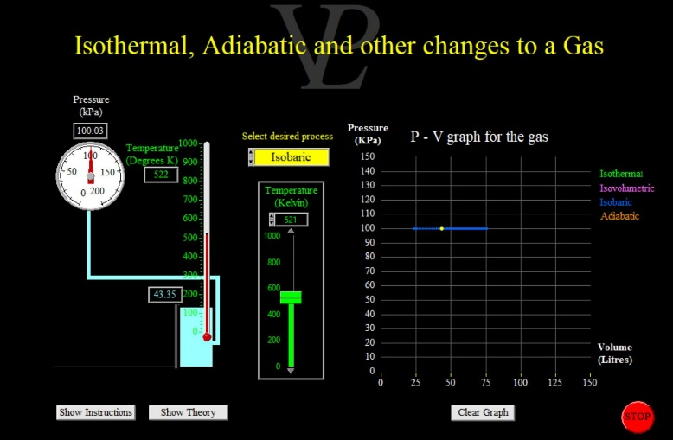
Image shows an isobaric process, where pressure remains constant at around 100 kPa, while temperature increases from 521 K to 522 K. The volume increases, as expected based on Charles’ Law, which states that volume is directly proportional to temperature at constant pressure.
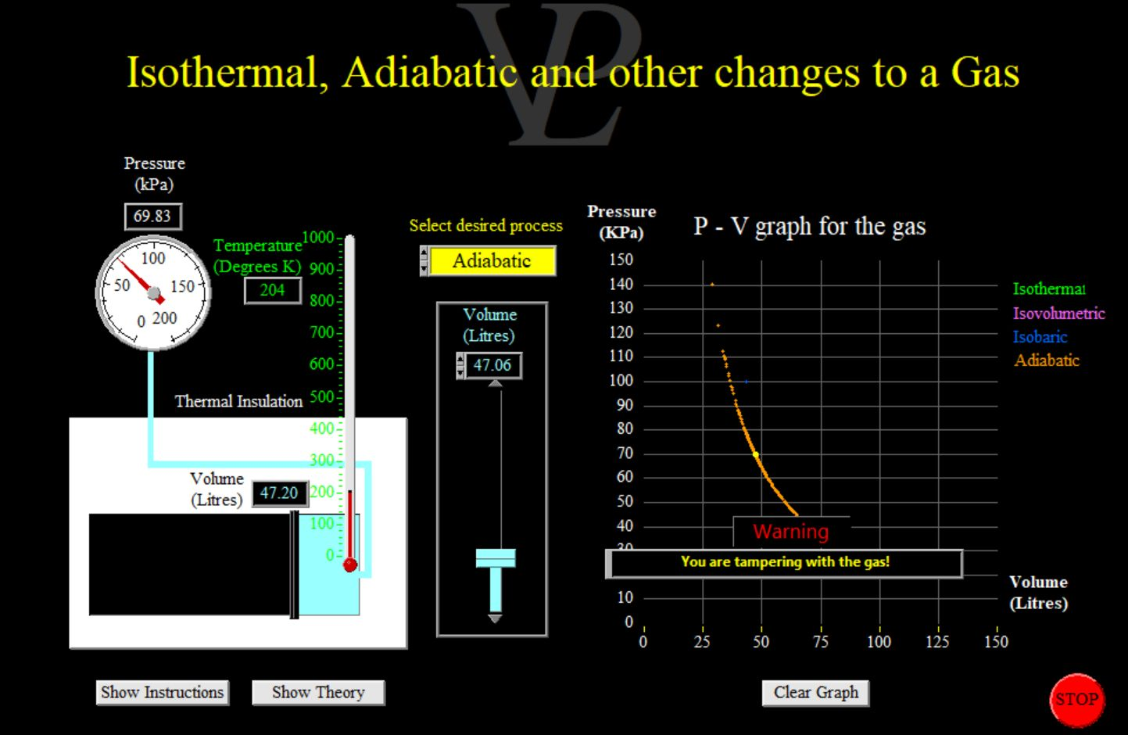
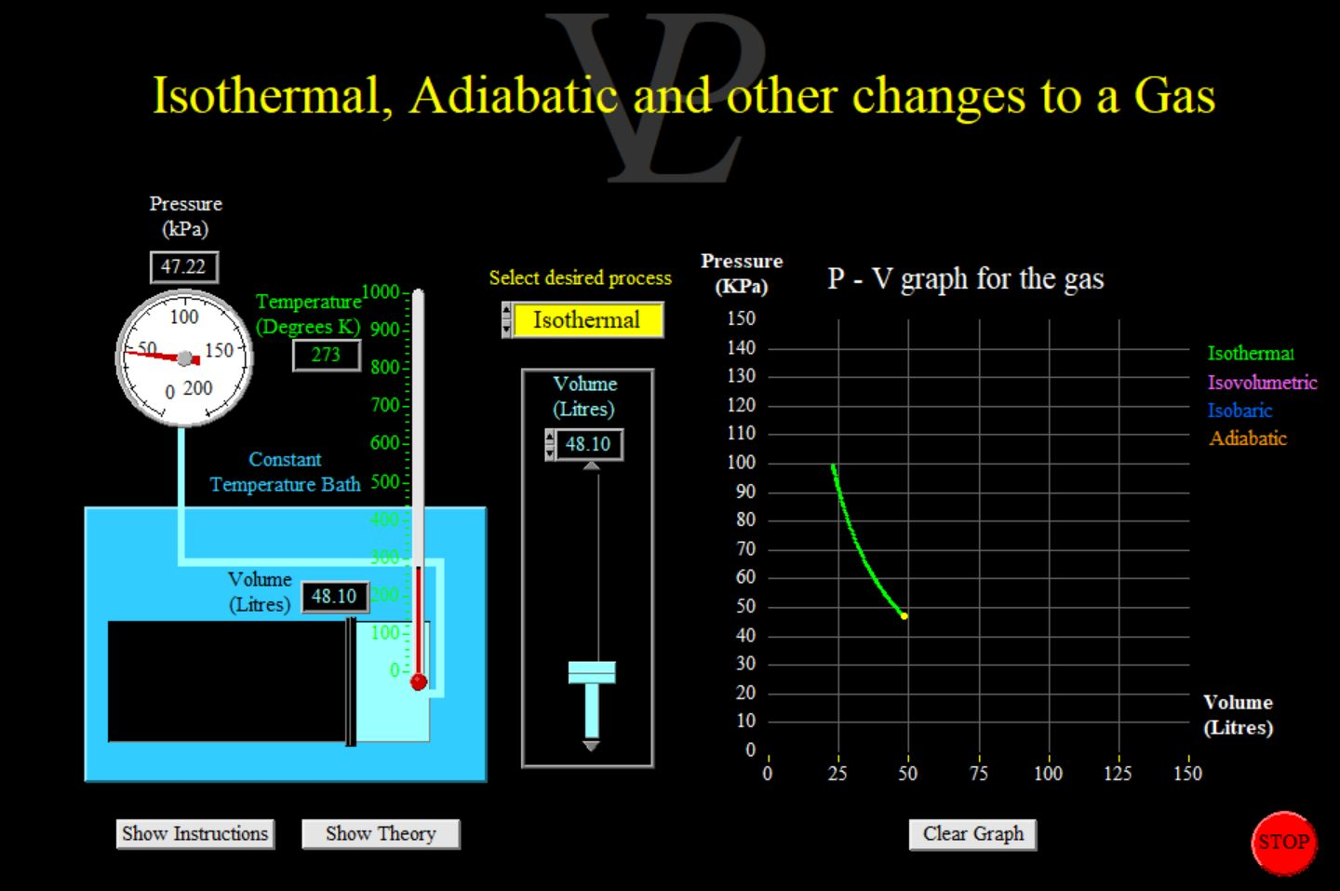
I
mage represents an isothermal process, where temperature is maintained at 273 K, and pressure decreases from around 100 kPa to 47.22 kPa.

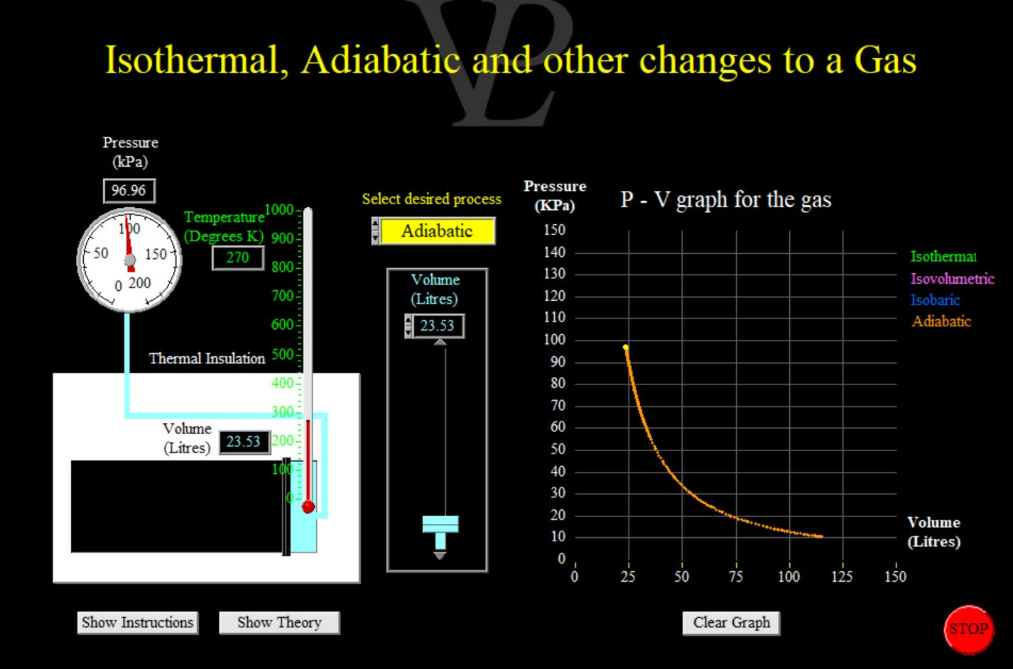
The third and fourth images display an adiabatic process, where temperature drops significantly from 270 K to 204 K, and pressure decreases from around 96.96 kPa to 69.83 kPa.

The experimental results confirmed theory predictions for isobaric, isothermal, and adiabatic processes. In isobaric process, pressure remained constant at approximately 100 kPa and temperature decreased from 521 K to 522 K with a corresponding proportional increase in volume. This is in agreement with Charles’ Law as a straight-line relationship between volume and temperature in a graph is found. The isothermal process at constant temperature of 273 K resulted in a decrease in pressure from 100 kPa to approximately 47.22 kPa with a corresponding P-V curve in a hyperbolic shape as explained by Boyle’s Law. The adiabatic process involved a steep decrease in pressure and volume with a steep decrease in temperature as would be found in an adiabatic transformation in which no exchange of heat with surroundings is involved. The P-V curve for this process portrayed an exponential decrease. These observations were confirmed visually through simulation-generated graphs that clearly described the various thermodynamic behaviors. The experimental data were processed through mathematical equations and calculations were made for work done, heat transfer, and internal energy changes.
Discussion and Conclusion
The experiment successfully verified the theory behind isobaric, isothermal, and adiabatic transformations. The volume rise with temperature at constant pressure in the isobaric simulation complied with Charles’ Law and pressure-volume relationship in the isothermal process complied with Boyle’s Law. The adiabatic transformation had steep pressure and volume reductions typical of an insulated system where changes in energy are made without external exchange of heat. These results reinforce the application of thermodynamics in engineering and energy-based systems such as in gas turbines, refrigeration cycles, and internal combustion engines. The simulation method provided a controlled setup to study these transformations with minimal experimental uncertainties. Small variations in observed values could be explained by simulation software precision limits. Future improvement would be to conduct experiments with real gases to include departures from ideal behavior. In conclusion, this experiment reiterated the fundamental laws of thermodynamics and demonstrated their application in engineering and energy-based systems.

References
- Cengel, Y. A., & Boles, M. A. (2019). Thermodynamics: An Engineering Approach. McGraw-Hill Education.
- Moran, M. J., Shapiro, H. N., Boettner, D. D., & Bailey, M. B. (2018). Fundamentals of Engineering Thermodynamics. John Wiley & Sons.
- Smith, J. M., Van Ness, H. C., & Abbott, M. M. (2021). Introduction to Chemical Engineering Thermodynamics. McGraw-Hill Education.

